Country: Iraq
Type: Protection of Civilians
Date: 22 May to 28 June 2016
Covering: Fallujah, Iraq
Focal Points: Humanitarian Coordinator, OCHA CMCoord, Protection Cluster
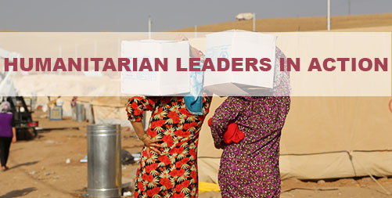

- Senior leadership to protect civilians

The Humanitarian Coordinator worked with a wide range of key political, military and diplomatic decision-makers seeking concrete measures to protect civilians inside Fallujah and those attempting to escape. Major efforts were also taken by the civil-military liaison team and protection partners. The steps taken included:

- Engage in direct, real time diplomacy with Iraqi leaders and security forces to minimise casualties and protect civilians
- Reach out through the media to influence the behaviour of the parties to the conflict
- Track conditions on the ground through local networks and channelling real-time information on evacuation routes and the location of the informal screening sites to families attempting to flee
- Engage with military commanders on the location and management of evacuation routes
- Engage with political and diplomatic leaders on the location and conditions in formal and informal screening sites

- Establish networks to supply real time information on the protection situation of the civilian population.

- Use Humanitarian Civil Military Coordination experts for information collection, networking, and advocacy.

- Use an International Humanitarian Law and Human Rights framework in public and private advocacy.

- Convene a small group of HCT members led by the HC to coordinate advocacy. Build on the complementarities of HCT members who have access to different types of stakeholders. Utilise the good offices of HCT members, the Humanitarian Coordinator and SRSG for advocacy.

- Establish a network of interlocutors with influence over parties to the conflict (e.g influential Ambassadors).

- Develop a short, practical, operational framework to guide front-line humanitarian workers faced with protection dilemmas. Base it on the core humanitarian principles, do no harm and international humanitarian and human rights law. The Inter Cluster Coordination Group should lead development with endorsement from the Humanitarian Country Team. Disseminate widely to front line staff.

Practical steps for leaders to put the centrality of protection into practice

Protecting Civilians in Armed Conflicts
The Centrality of Protection

From 22 May to 28 June 2016, Iraqi security forces sought to recapture Fallujah and its surrounding suburbs from ISIL. More than 100,000 civilians were in areas where fighting occurred, raising serious and sensitive questions about protection of civilians and the conduct of hostilities. By end of June, over 85,000 civilians had fled. During the military operation, civilians were at extreme risk from cross-fire, artillery and IEDs. In a number of instances, families were at risk as they tried to escape along evacuation routes. Serious abuses at informal screening sites, including torture and disappearances, were reported.
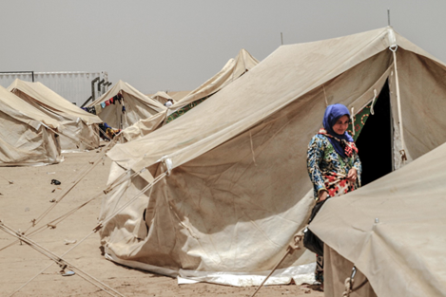

- Making use of the humanitarian principles to deal with operational dilemmas
Humanitarian organisations inevitably face acute protection and operational dilemmas in front-line operations. With the Fallujah operation, actors faced the dilemma of whether to provide humanitarian services in screening centers where violations were reportedly occurring. This placed the humanitarian imperative against principles such as impartiality, do no harm and respect for fundamental human rights.

- Based on the efforts of the Shleter Cluster, the Protection Cluster worked to update one of the HCT's key protection documents, Taking a Principled Approach: Framework for Defining Humanitarian Engagement When Humanitarian and Protection Concerns are present.
- The intention of the framework is to provide front-line partners with concrete guidance on the parametres of operations when faced with protection dilemmas.
- The framework sets out the thresholds for engagement and provides guidance on the types of response. The process of developing the framework has been inclusive.
- The inter-Cluster Coordination Group requested a single document with concrete guidance on protection measures and policies. The Shelter/NFI cluster worked on early drafts, which were expanded on by the Protection Cluster and shared with the Inter-Cluster Coordination Group (ICCG). Each cluster has provided input to ensure practical applicability, with a colour coded – red, yellow and green - system. The HCT is currently reviewing the framework; once endorsed, the framework will be disseminated to all front-line partners.

“Protection is the foundation of all humanitarian work, and humanitarians have a duty to do all they can to protect civilians whenever and wherever they are at risk. Like never before, disrespect for International Humanitarian Law and the obligation to protect civilians is increasing. Nonetheless, and no matter how difficult the task, protection should be a central concern in all humanitarian operations”
Lise Grande, Deputy Special Representative of the Secretary General, Resident and Humanitarian Cooridnator in Iraq

Potential next steps for the response

- Build on and strengthen CMCoord capacity to support information gathering, networking and engagement.
- Strengthen engagement of HCT representatives to utilize their good offices and influence at their levels.
- Do not refer to the operational dilemmas framework as a ‘Red lines’ framework as it implies restrictive obligations. Emphasise that it is a tool to assist front line workers deal with operational dilemmas through a principled framework.
- Ensure that the framework is rolled out to front-line staff.
- Have International Humanitarian Law training for protection cluster members, including national and local partners.
- Look at opportunities for strengthening humanitarian advocacy competencies in humanitarian leaders.

Joint mission team
From 31 July to 5 August 2016, representatives from the STAIT, Global Protection Cluster, World Vision International, and AMEL sought to capture good practice on how leadership had supported the centrality of protection and Accountability to Affected People (AAP) in Iraq’s humanitarian response. The team travelled to Erbil and Baghdad, as well as undertaking a field visit to the camp in Debagaa. Over one hundred people were interviewed, including the Humanitarian Coordinator and Heads of relevant UN agencies, NGOs and clusters. Light desk reviews focused on Yemen and oPt for the centrality of protection and Burundi, Darfur and Nepal for AAP.

This information sheet is based on findings from a STAIT learning mission. For more information, please visit: http://www.deliveraidbetter.org/

